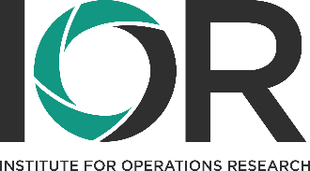


OR
V träge zum Operations Research
Kolloquium des Instituts für Operations Research

Zeit: | Mittwoch, 22. April 2026, 13:00 Uhr
Ort: | Bibliothek 5. Stock, Gebäude 01.87
Es spricht: | Prof. Dr. Klaus Herrmann, Université de Sherbrooke, Kanada
Zum Thema: | Morillas type distortions of joint distribution functions and their maximum domain of attraction

In this talk we revisit transformations of distribution functions, focusing on the transformation introduced by Morillas (2005) for copulas and multivariate distribution functions. We study properties of in such a way distorted joint distribution functions, focusing specifically on the limiting behavior of component-wise maxima. Our main result is a characterization of the possible maximum domain of attraction limits for Morillas type distorted dependence structures, as well as sufficient conditions that allow to identify the specific limiting distribution in a given case. We discuss links and similarities to the construction of Archimedean copulas and their respective extreme-value behavior. Finally, the impact of distortions on multivariate risk measures will be investigated.
This talk is based on joint work with Marius Hofert, Mélina Mailhot and Nahid Sadr.
References
Morillas, P. M. (2005). A method to obtain new copulas from a given one. Metrika, 61(2), 169-184.

Die Vorträge zum Operations Research wenden sich an alle Interessierten!

Bei Rückfragen wenden Sie sich bitte an:
Prof. Dr. Oliver Grothe, Institut für Operations Research

